**GDSC REPORT MAKING**

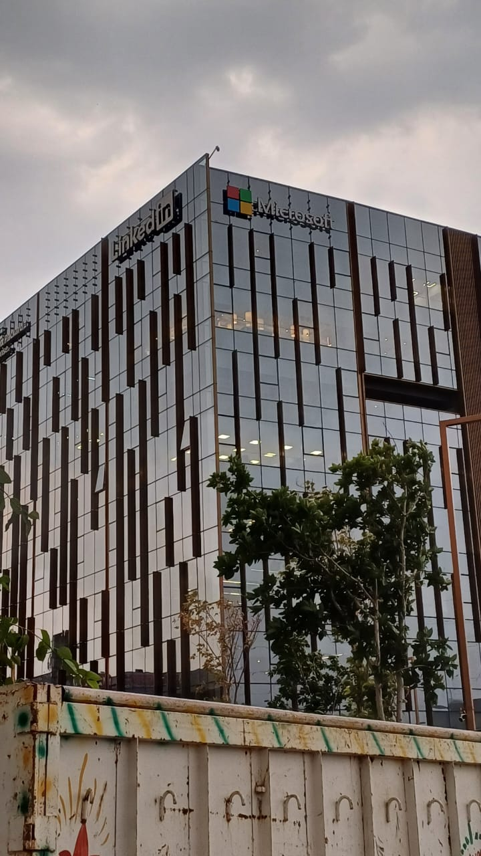

**ON 13 APRIL, 2024 AN EVENT AS ORGANISED BY MICROSFT OFFICE AT GURUGRAM , HARYANA FROM 11 AM ONWARDS . AS A MULTINATIONAL COORPORATION IT WAS ONE OF THE BEST EVENT WHICH BASED ON “CARRER”. THE MOTIVE WAS “ CARRER MEETUP” , AS IT WAS A DISCUSSION BASED PROGRAM WITH INDUSTRY EXPERTS.**

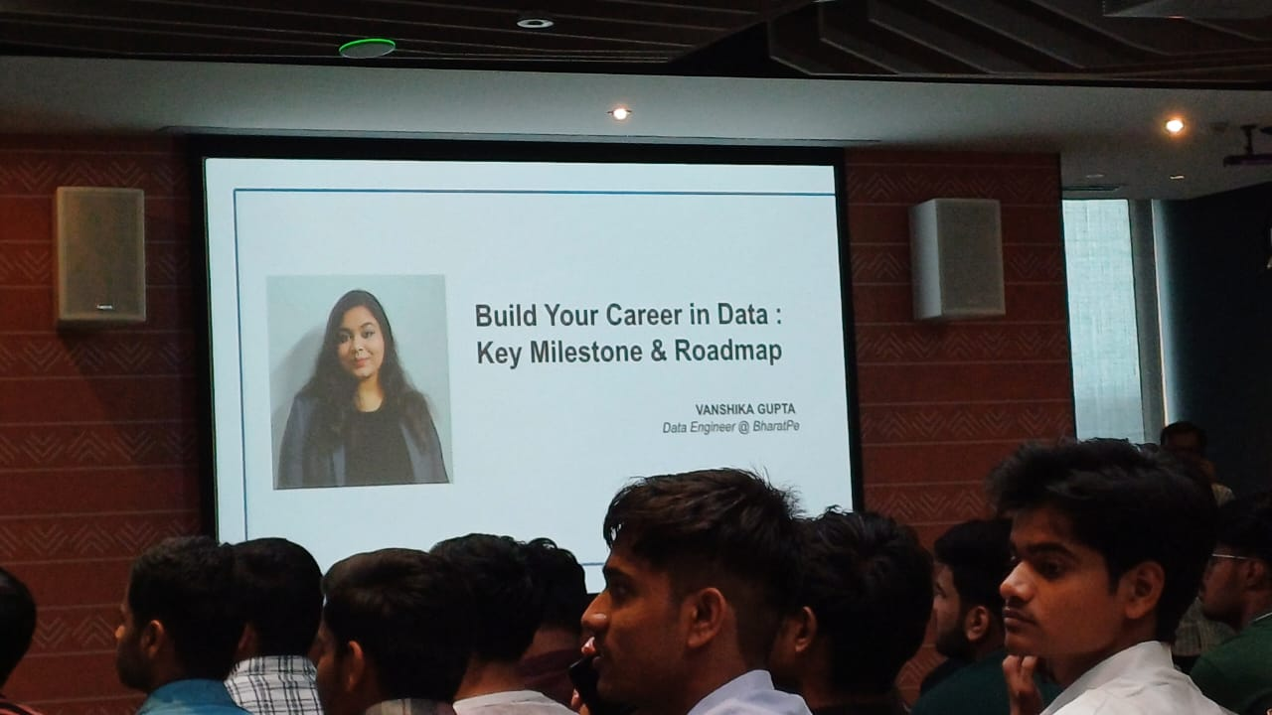

**THERE WERE TWO SPEAKERS , ONE WAS MR HITESH AN ” ARCHITECT SOLUTION” AT MICROSOFT AND ANOTHER WAS MS VANSHIKA GUPTA , A DATA SCIENTIST AT BHARATPAY. BOTH HAS EXPLAINED IN DEPTH ABOUT MANY ASPECTS OF TECHNICAL FIELDS WHICH WAS TRUTHFUL AND ENCOURAGING FOR ALL TECHNICAL STUDENTS. IT WAS A BOOSTING AND MOTIVATING FOR NON- TECHNICAL STUDENTS AS WELL.**

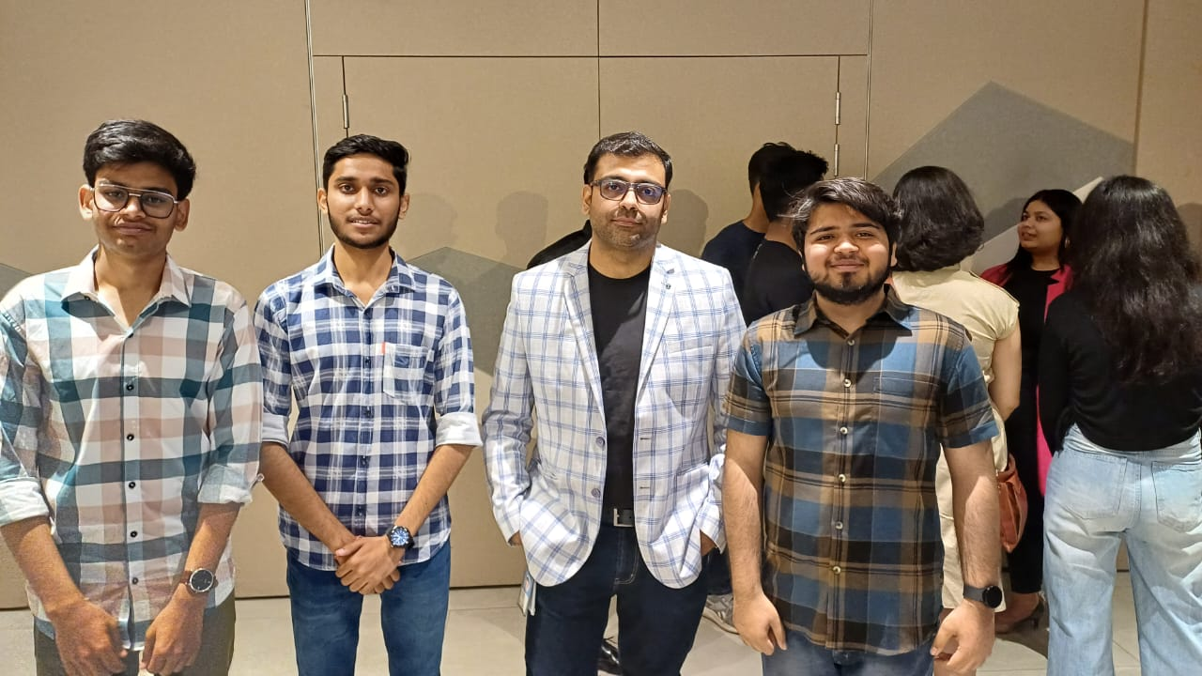

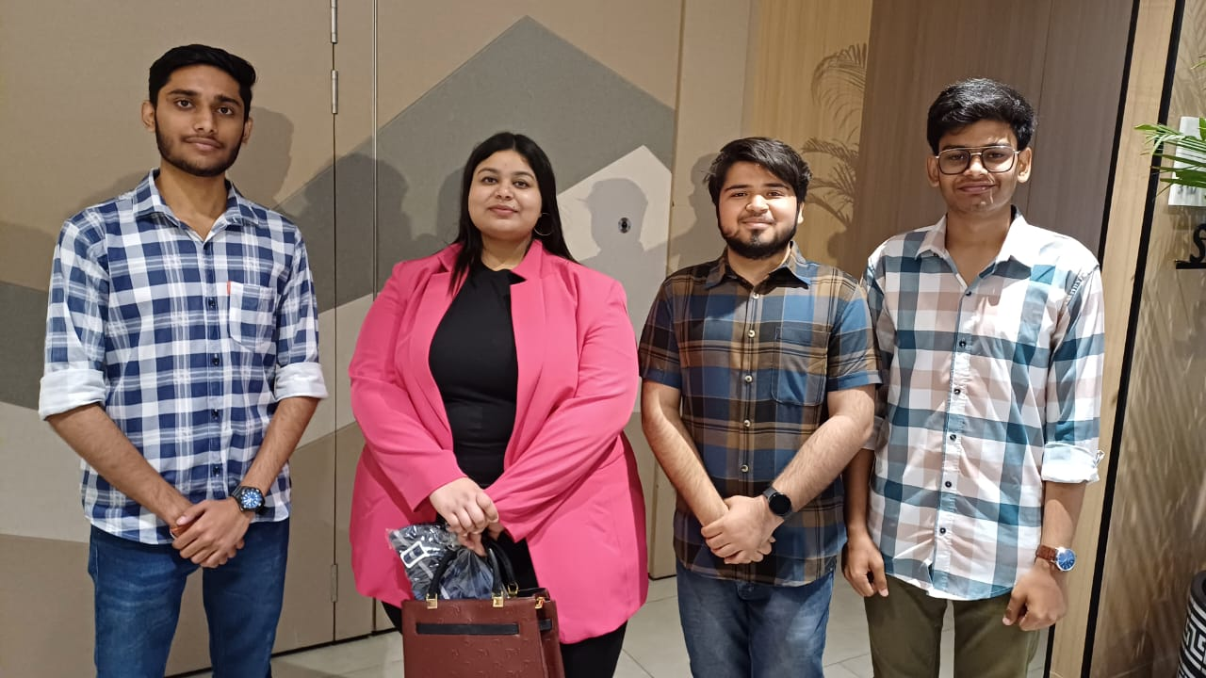

**. The first speaker MR Hitesh explained about job of a solution architect, who can become and how to become a solution architect and how does a solution architect tackle with real world problems and with a business and tech mindset create solutions or build products that solve a real world problem.**

**The second speaker MS vanshika gupta explained about data science, the role of data engineer, data analyst, cybersecurity engineer and analyst and a data scientist. She explained the role of data in industrial metaverse along with importance of AI/ML in technical field.**

**THIS EVENT GOT WELL AND STUDENTS LEARNT SO MANY THINGS.**

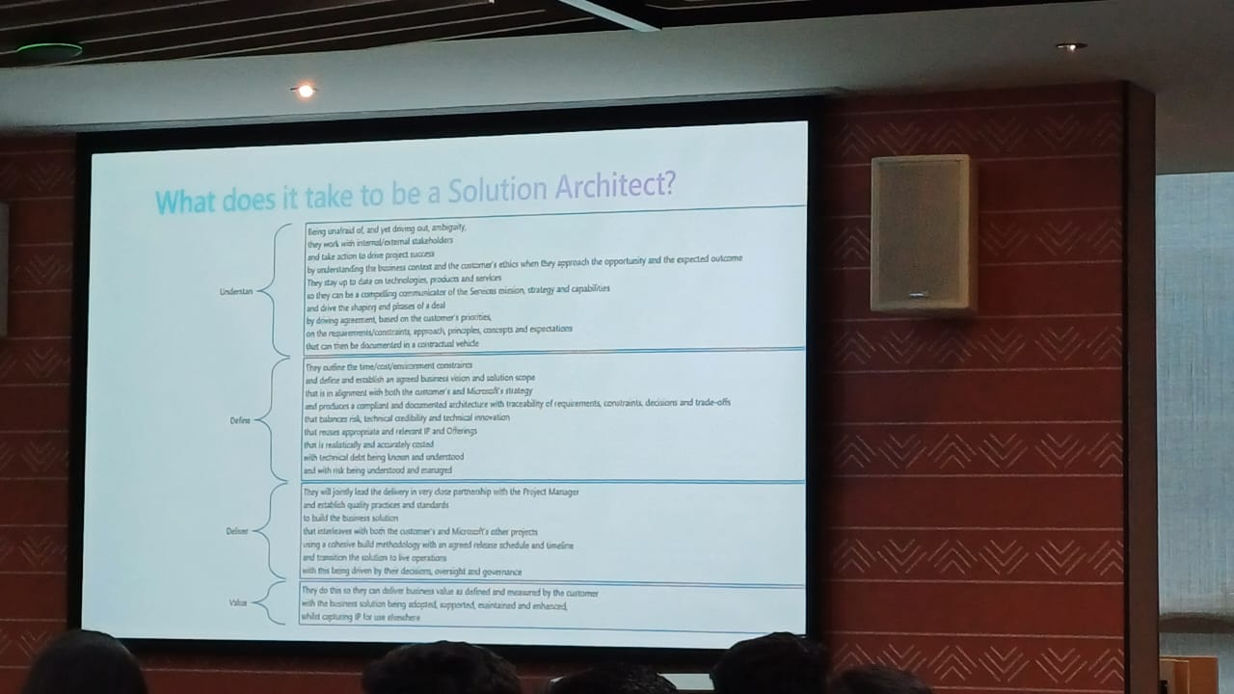

**THANK YOU**